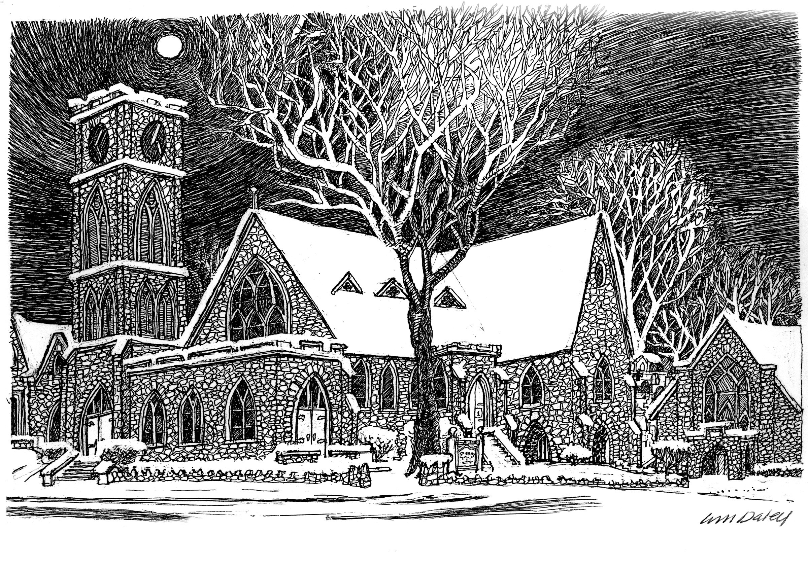

Unto Us, A Child Is Born

Christmas Eve

December 24, 2025 7 p.m.

Welcome to St. Paul’s Elkins Park!
We are on a mission to know Christ; to make Christ known in our community; and to follow His Way of compassion and service to others.
The Rev. John D. Daniels, Priest in Charge
The Rev. Simpson Coriolan, Priest Associate
The Rev. Jeannie Sachs, Deacon
David Antony Lofton, Music Director
Tessika McClendon, Soprano Shango-Jamal Lewis, Baritone
Veronica Flemings, Acolyte

Cover: Drawing by William Daley

Holy Eucharist
The Ministry of the Word

Prelude:

WELCOME

Opening Hymn:

Opening Sentence: Please Stand

Celebrant: Blessed be the Lord Our God.
People: For ever and ever.
Celebrant: We seek to walk the path of Christ.
People: May the Spirit be among us, in us, and through us.
Hymn of Glory: This is the Day LEVAS #219
Celebrant: The Lord be with you. People: And also with you. Celebrant: Let us pray.

The Collect: Celebrant: Almighty God, you have given your only-begotten Son to take our nature upon him, and to be born [this day] of a pure virgin: Grant that we, who have been born again and made your children by adoption and grace, may daily be renewed by your Holy Spirit; through our Lord Jesus Christ, to whom with you and the same Spirit be honor and glory, now and forever. Amen.

The First Lesson: A reading from the Old Testament: Isaiah 7:10-16
Please be seated for the readings.

The people who walked in darkness have seen a great light; those who lived in a land of deep darkness— on them light has shined. ³You have multiplied the nation, you have increased its joy; they rejoice before you as with joy at the harvest, as people exult when dividing plunder. ⁴For the yoke of their burden, and the bar across their shoulders, the rod of their oppressor, you have broken as on the day of Midian. ⁵For all the boots of the tramping warriors and all the garments rolled in blood shall be burned as fuel for the fire. For a child has been born for us, a son given to us; authority rests upon his shoulders; and he is named Wonderful Counselor, Mighty God, Everlasting Father, Prince of Peace. His authority shall grow continually, and there shall be endless peace for the throne of David and his kingdom. He will establish and uphold it with justice and with righteousness from this time onward and forevermore. The zeal of the Lord of hosts will do this.

Reader: The Word of the Lord. People: Thanks be to God.
Psalm: Psalm 96
Sing to the Lord a new song; *
sing to the Lord, all the whole earth.
Sing to the Lord and bless his Name; *
proclaim the good news of his salvation from day to day.
Declare his glory among the nations *
and his wonders among all peoples.
For great is the Lord and greatly to be praised; *
he is more to be feared than all gods.
As for all the gods of the nations, they are but idols; *
but it is the Lord who made the heavens.
Oh, the majesty and magnificence of his presence! *
Oh, the power and the splendor of his sanctuary!
Ascribe to the Lord, you families of the peoples; *
ascribe to the Lord honor and power.
Ascribe to the Lord the honor due his Name; *
bring offerings and come into his courts.
Worship the Lord in the beauty of holiness; *
let the whole earth tremble before him.
Tell it out among the nations: “The Lord is King! *
he has made the world so firm that it cannot be moved;
he will judge the peoples with equity.”
Let the heavens rejoice, and let the earth be glad;
let the sea thunder and all that is in it; *
let the field be joyful and all that is therein.
Then shall all the trees of the wood shout for joy
before the Lord when he comes, *
when he comes to judge the earth.
He will judge the world with righteousness *
and the peoples with his truth.
The Second Lesson: Titus 2:11-14
For the grace of God has appeared, bringing salvation to all, training us to renounce impiety and worldly passions, and in the present age to live lives that are self-controlled, upright, and godly, we wait for the blessed hope and the manifestation of the glory of our great God and Savior, Jesus Christ.
He it is who gave himself for us that he might redeem us from all iniquity and purify for himself a people of his own who are zealous for good deeds.
Hear what the Spirit is saying to God’s people. People: Thanks be to God.
Gospel Hymn:
The Gospel: All Stand for the reading of the Gospel Celebrant: Holy Gospel of our Lord Jesus Christ according Luke 2:1-14 People: Glory to you, Lord Christ
In those days a decree went out from Emperor Augustus that all the world should be registered. was the first registration and was taken while Quirinius was governor of Syria. All went to their own towns to be registered. Joseph also went from the town of Nazareth in Galilee to Judea, to the city of David called Bethlehem, because he was descended from the house and family of David. He went to be registered with Mary, to whom he was engaged and who was expecting a child. While they were there, the time came for her to deliver her child. And she gave birth to her firstborn son and wrapped him in bands of cloth, and laid him in a manger, because there was no place for them in the inn.
In that region there were shepherds living in the fields, keeping watch over their flock by night. Then an angel of the Lord stood before them, and the glory of the Lord shone around them, and they were terrified. But the angel said to them, “Do not be afraid; for see—I am bringing you good news of great joy for all the people: to you is born this day in the city of David a Savior, who is the Messiah, the Lord. This will be a sign for you: you will find a child wrapped in bands of cloth and lying in a manger.” And suddenly there was with the angel a multitude of the heavenly host, praising God and saying, “Glory to God in the highest heaven, and on earth peace among those whom he favors!”
Celebrant: The Gospel of the Lord People: Praise to you, Lord Christ.
The Homily: The Rev. John D. Daniels
The Nicene Creed All Stand as you are able Our Affirmation of Trust in all that is Holy We believe in one God, the Father, the Almighty, maker of heaven and earth, of all that is, seen and unseen. We believe in one Lord, Jesus Christ, the only Son of God, eternally begotten of the Father, God from God, Light from Light, true God from true God, begotten, not made, of one Being with the Father. Through him all things were made. For us and for our salvation he came down from heaven: by the power oy Spirit he became incarnate from the Virgin Mary and was made man. For our sake he was crucified under Pontius Pilate; he suffered death and was buried. On the third day he rose again in accordance with the Scriptures; he ascended into heaven and is seated at the right hand of the Father. He will come again in glory to judge the living and the dead, and his kingdom will have no end. We believe in the Holy Spirit, the Lord, the giver of life, who proceeds from the Father and the Son. With the Father and the Son he is worshiped and glorified. He has spoken through the Prophets. We believe in one holy catholic and apostolic Church. We acknowledge one baptism for the forgiveness of sins. We look for the resurrection of the dead, and the life of the world to come. Amen.
Prayers of the People: (The Reader and People pray responsively)
In peace, we pray to you, Lord God. (Silence) For all people in their daily life and work; For our families, friends, and neighbors, and for those who are alone. For Congress and the President, for peace among the nations, for all those in uniform now serving in harm’s way, and for those who suffer for the sake of conscience. For all who work for justice, freedom, and peace. For the just and proper use of your creation; For the victims of hunger, fear, injustice, and oppression. For all who are in danger, sorrow, or any kind of trouble; For those who minister to the sick, the friendless, and the needy. Give us hope in this time of uncertainty. Strengthen those who are afraid and give us courage in the face of violence and hate. Open our hearts and the hearts of our enemies to your ways of peace; break down the walls that divide us. Make us instruments of reconciliation and show forth your love. For the peace and unity of the Church of God; For all who proclaim the Gospel, and all who seek the Truth. For Sean, our Presiding Bishop, for Daniel, our Diocesan Bishop; for John, our Priest in Charge, for Simpson, our Priest Associate, for Jeannie, our Deacon, for David our Music Director, for Tessika and Shango-Jamal, our singers, for Veronica, our acolyte, and for all bishops and other ministers, and for all people everywhere; For all who serve in God’s Church. For the special needs and concerns of this congregation, (The People may add their own petitions, either silently or aloud) Hear us, Lord; For your mercy is great. We thank you, Lord, for all the blessings of this life. (The People may add their own thanksgivings either silently or aloud) We will exalt you, O God our King; And praise your Name for ever and ever. We pray for all who have died, that they may have a place in your eternal kingdom. (The People may pray for those who have died, silently or aloud.) Lord, let your loving-kindness be upon them; Who put their trust in you.
Celebrant and People: Almighty God, to whom our needs are known before we ask, help us to ask only what accords with your will; and those good things which we dare not, or in our blindness cannot ask, grant us for the sake of your Son Jesus Christ our Lord. Amen. Confession of Sin: Celebrant Let us confess our sins against God and our neighbors. Celebrant and People Most merciful God, in thought, word, and deed, by what we have done, and by what we have left undone. We have not loved you with our whole heart; we have not loved our neighbors as ourselves. We are truly sorry and we humbly repent. For the sake of your Son Jesus Christ, have mercy on us and forgive us; that we may delight in your will, and walk in your ways, to the glory of your Name. Amen.
Celebrant: Almighty God have mercy on you, forgive you all your sins through our Lord Jesus Christ, strengthen you in all goodness, and by the power of the Holy Spirit keep you in eternal life. Amen.
The Peace: (All stand.) Celebrant: The peace of Christ be always with you. People: And also with you. (The Ministers and People greet one another in the name of the Lord.)
Words of Welcome and Announcements

The Holy Communion
Eucharistic Prayer
Offertory Anthem:
The Doxology #380 verse Praise God from whom all blessings flow Praise Him all creatures here below Praise Him above ye heavenly host Praise Father, Son and Holy Ghost. Amen.
Celebrant: The Lord be with you. People: And also with you.
Celebrant: Lift up your hearts.
People: We lift them up to the Lord.
Celebrant: Let us give thanks to the Lord our God.
People: It is right to give our thanks and praise.

Facing the Holy Table, the Celebrant says It is truly right, and good and joyful, to give you thanks, all-holy God, source of life and fountain of mercy. You have filled us and all creation with your blessing and fed us with your constant love; you have redeemed us in Jesus Christ and knit us into one body.
Through your Spirit you replenish us and call us to fullness of life. Therefore, joining with Angels and Archangels and with the faithful of every generation, we lift our voices with all creation as we sing:

Celebrant and People: Sanctus Blue Hymnal # S 124
Holy, Holy, Lord, God of power and might,
Heaven and earth are full of your glory.
Hosanna in the highest.
Blessed is he who comes in the name of the Lord. Hosanna in the highest.
Celebrant: Blessed are you, gracious God, creator of the universe and giver of life.
You formed us in your own image and called us to dwell in your infinite love. You gave the world into our care that we might be your faithful stewards. But we failed to honor your image in one another and in ourselves; we would not see your goodness in the world around us; and so we violated your creation, abused one another, rejected your love. Yet you never ceased to care for us, and prepared the way of salvation for all people. Through Abraham and Sarah, you called us into covenant with you. You delivered us from slavery, sustained us in the wilderness, and raised prophets to renew your promise of salvation. Then, in the fullness of time, you sent your eternal Word, made mortal flesh in Jesus. Born into the human family, and dwelling among us, he revealed your glory. Giving himself freely to death on the cross, he triumphed over evil, opening the way of freedom and life.
On the night before he died for us, Our Savior Jesus Christ took bread, and when he had given thanks to you, he broke it, and gave it to his friends, and said: “Take, eat: This is my Body which is given for you. Do this for the remembrance of me.” As supper was ending, Jesus took the cup of wine, and when he had given thanks, he gave it to them, and said: “Drink this, all of you: This is my Blood poured out in forgiveness. Whenever you drink it, do this for the remembrance of me.”
Therefore, we proclaim the mystery of faith: Celebrant and People:
Christ has died. Christ is risen. Christ will come again.
Celebrant: Remembering his death, resurrection, and ascension, we now present to you from your creation this bread and this wine. By your Holy Spirit may they be for us the Body and Blood of our Savior Jesus Christ. Grant that we who share these gifts may be filled with the Holy Spirit and live as Christ’s Body in the world. Bring us into the everlasting heritage of your daughters and sons, that with St. Paul and all your saints, past, present, and yet to come, we may praise your Name forever. Through Christ and with Christ and in Christ, in the unity of the Holy Spirit, to you be honor, glory, and praise, forever and ever. Amen.
Celebrant: And now, let us say together the words Our Savior taught us, Celebrant and People:
Our Father, who art in heaven as we forgive those
Hallowed be thy Name who trespass against us,
Thy kingdom come, and lead us not into temptation,
Thy will be done, but deliver us from evil,
On earth as it is in heaven. for thine is the kingdom,
Give us this day our daily bread, and the power, and the glory,
And forgive us our trespasses, forever and ever. Amen

The Breaking of the Bread (The Celebrant breaks the consecrated Bread.)
Celebrant: We break this bread to share in the Body of Christ. People: We who are many are one body, for we all share in the one bread and the one cup. Alleluia
Agnus Dei Blue Hymnal # S161
Lamb of God, you take away the sins of the world.
Have mercy on us.
Lamb of God you take away the sins of the world
Have mercy on us.
Lamb of God you take away the sins of the world, grant us peace.
Celebrant: The Gifts of God for the People of God. All are welcome at the Lord’s table. Take them in remembrance that Christ died for you, and feed on him in your hearts by faith, with thanksgiving. The ministers receive the Sacrament in both kinds, and then immediately deliver it to the people. The Bread and the Cup are given to the communicants.

Post Communion Prayer: After Communion, the Celebrant says, Let us pray. Celebrant and People
Loving God, we give you thanks for restoring us in your image, and nourishing us with spiritual food in the Sacrament of Christ’s Body and Blood.
Now send us forth a people, forgiven, healed, renewed; that we may proclaim your love to the world and continue in the risen life of Christ our Savior. Amen.
Candle Lighting:
Candles are lit to celebrate the Light of Christ coming into the world.
[As Ushers will proceed down the center aisle with lit tapers to light the first candle in each aisle. At the first notes of Silent Night, Ushers will begin to turn down the lights as we sing Silent Night.]
Hymn: Silent Night, Holy Night
Silent night, holy night All is calm, all is bright “Round yon Virgin Mother and Child Holy Infant so tender and mild Sleep in heavenly peace
Silent night, holy night Shepherds quake at the sight Glories stream from haven afar Heavenly host sing, Alleluia” Christ the Savior is born Christ the Savior is born
Silent night, holy night Son of God, love’s pure light Radiant beams from Thy holy face With the dawn of redeeming grace Jesus, Lord at Thy birth Jesus, Lord at Thy birth

Christmas Blessing:
Celebrant: May the peace of Christ go with you, wherever He may send you. May He guide you through the wilderness, protect you through the storm. May He bring you home rejoicing at the wonders He has shown you. And may the blessing of God Almighty, Creator, Redeemer, and Sanctifier, be with you and those you love, this day and forever more. Amen. People: Amen.
Closing Hymn:
The Dismissal: Celebrant: Let us go forth into the world, rejoicing in the power of the Spirit. Alleluia. Alleluia. People: Thanks be to God. Alleluia, alleluia.

Postlude:

***

December Birthday’s
02- Gail Taylor 20- Chiedozie Anyanechi 23- Walter Runge 26- Karen Bailey 27- Anne Reid
Anniversary – Gil & Laurinda Hoffer 12/06

St. Paul's Women's Book Club
The next meeting of St. Paul's Women's book club will be Wednesday, January 28, 2026, at 7 p.m. Carlene Wells is hosting at 811 Chelten Hills Drive. We will be discussing Three Days in June by Anne Tyler. Please join us!

The Giving Tree -“Thank You” To All who donated gifts from the “Giving Tree”. Gifts are for the Children of Bilingual Occupational Therapy. Gifts can be left under the Giving Tree in the Narthex. Thank You Danielle Taylor Hand for planning the Giving Tree this year. If you have someone (family, friends, group or organization would be a benefit from the giving tree, or if you would like to be a part of the Giving Tree Team, please contact Danielle.

Thank You to David Lofton, Music Director and Shango-Jamal Lewis, Director Friends of St. Paul’s, for the Wonderful Concert last Saturday. Thank you, to all the performers, and all those that came out to support and enjoy a wonderful evening of “Bach, Baroque, and Beyond”.

Save the Date: April 11, 2026 4p.m. –A Recital with Tessika McClendon soprano, Belinda Whitnley, violin, David Anthony Lofton, Piano.
Featuring music of John Carter, Ernest Chausson, Camille Saint-Saems, James H. Easst, Sergei Rachmaninoff, and Moses Hogan. April

Food Pantry – Remember to Donate to the Food Pantry Wagon in the Narthex.

New Worship Committee – The Worship Committee is forming and will meet the 4st Sunday of every month following the 9 am service. Committee members offer support and planning to the ministers, during regular and special services. Members include Greeters/Ushers, Acolytes, Altar Guild and anyone interested in helping.
Please contact Karen Bailey for more information.

The Prayer Shawl Knitting Group will resume meeting the Second Saturday of each month starting in February. Weather permitting.

Finance & Property Meeting – Thursday, January 8.
Vestry Meeting – Tuesday, January 13.


An Inclusive Multicultural Episcopal Church
We are on a mission to know Christ and follow His Way of compassion
and service.
Fundamental Fairness
Do not let people disappear!
We support due process - a fundamental principle of fairness in legal proceedings, ensuring that individuals are treated fairly by the government.
We celebrate multicultural traditions. We are faithful, caring, and accepting.
All Are Welcome – No Exceptions
Please Join Us!
Family Communion, Sunday 9:00am
St. Paul’s Church, 7809 Old York Road Elkins Park, PA 19027 (215-635-4185) stpaulselkinspark.org office@stpaulselkinspark.org

