
20 Sunday After Pentecost October 26, 2025 9:00 a.m. Proper 25
Welcome to St. Paul’s Elkins Park!
We are on a mission to know Christ; to make Christ known in our community; and to follow His Way of compassion and service to others.
The Rev. John D. Daniels, Priest in Charge
The Rev. Simpson Coriolan, Priest Associate
The Rev. Jeannie Sachs, Deacon
David Antony Lofton, Music Director
Tessika McClendon, Soprano Shango-Jamal Lewis, Baritone

Holy Eucharist
The Ministry of the Word
Prelude: Shall We Gather At The River arr. Greg Howlett

WELCOME

Opening Hymn: Love Devine, All Loves Excelling Blue #657 vs. 1, 3

Opening Sentence:
Please Stand

Celebrant: Blessed be the Lord Our God.
People: For ever and ever.
Celebrant: We seek to walk the path of Christ.
People: May the Spirit be among us, in us, and through us.
Hymn of Glory: Glory To God LEVAS #53
Celebrant: The Lord be with you. People: And also with you. Celebrant: Let us pray.

The Collect: Celebrant:
Almighty and everlasting God, increase in us the gifts of faith, hope, and charity; and, that we may obtain what you promise, make us love what you command; through Jesus Christ our Lord, who lives and reigns with you and the Holy Spirit, one God, forever. Amen.

The First Lesson: A reading from the Old Testament: Genesis 32:22-31 Please be seated for the readings.
Old Testament: Sirach 35:12-17
Give to the Most High as he has given to you,
and as generously as you can afford.
For the Lord is the one who repays,
and he will repay you sevenfold.
Do not offer him a bribe, for he will not accept it;
and do not rely on a dishonest sacrifice;
for the Lord is the judge,
and with him there is no partiality.
He will not show partiality to the poor;
but he will listen to the prayer of one who is wronged.
He will not ignore the supplication of the orphan,
or the widow when she pours out her complaint. Amen
Reader: The Word of the Lord. People: Thanks be to God.
Psalm 84:1-6
How dear to me is your dwelling, O Lord of hosts! *
My soul has a desire and longing for the courts of
the Lord; my heart and my flesh rejoice in the living God.
The sparrow has found her a house
and the swallow a nest where she may lay her young; *
by the side of your altars, O Lord of hosts,
my King and my God.
Happy are they who dwell in your house! *
they will always be praising you.
Happy are the people whose strength is in you! *
whose hearts are set on the pilgrims’ way.
Those who go through the desolate valley will find
it a place of springs, *
for the early rains have covered it with pools of water.
They will climb from height to height, *
and the God of gods will reveal himself in Zion.
The Second Lesson: 2 Timothy 4:6-8, 16-18
As for me, I am already being poured out as a libation, and the time of my departure has come. ⁷I have fought the good fight, I have finished the race, I have kept the faith. ⁸From now on there is reserved for me the crown of righteousness, which the Lord, the righteous judge, will give me on that day, and not only to me but also to all who have longed for his appearing.
At my first defense no one came to my support, but all deserted me. May it not be counted against them! ¹⁷But the Lord stood by me and gave me strength, so that through me the message might be fully proclaimed, and all the Gentiles might hear it. So, I was rescued from the lion’s mouth.¹⁸The Lord will rescue me from every evil attack and save me for his heavenly kingdom. To him be the glory forever and ever. Amen.
Hear what the Spirit is saying to God’s people. People: Thanks be to God.
Gospel Hymn: I Heard the Voice of Jesus Say Blue #692 vs. 1, 3
The Gospel: All Stand for the reading of the Gospel Celebrant: Holy Gospel of our Lord Jesus Christ according to Luke 18:9-14 People: Glory to you, Lord Christ
He also told this parable to some who trusted in themselves that they were righteous and regarded others with contempt: “Two men went up to the temple to pray, one a Pharisee and the other a tax collector. The Pharisee, standing by himself, was praying thus, ‘God, I thank you that I am not like other people: thieves, rogues, adulterers, or even like this tax collector. I fast twice a week; I give a tenth of all my income.’ But the tax collector, standing far off, would not even look up to heaven, but was beating his breast and saying, ‘God, be merciful to me, a sinner!’ I tell you, this man went down to his home justified rather than the other; for all who exalt themselves will be humbled, but all who humble themselves will be exalted.”
Celebrant: The Gospel of the Lord People: Praise to you, Lord Christ.
The Homily: The Rev. Jeannie Sachs, Deacon
The Nicene Creed All Stand as you are able Our Affirmation of Trust in all that is Holy We believe in one God, the Father, the Almighty, maker of heaven and earth, of all that is, seen and unseen. We believe in one Lord, Jesus Christ, the only Son of God, eternally begotten of the Father, God from God, Light from Light, true God from true God, begotten, not made, of one Being with the Father. Through him all things were made. For us and for our salvation he came down from heaven: by the power oy Spirit he became incarnate from the Virgin Mary and was made man. For our sake he was crucified under Pontius Pilate; he suffered death and was buried. On the third day he rose again in accordance with the Scriptures; he ascended into heaven and is seated at the right hand of the Father. He will come again in glory to judge the living and the dead, and his kingdom will have no end. We believe in the Holy Spirit, the Lord, the giver of life, who proceeds from the Father and the Son. With the Father and the Son he is worshiped and glorified. He has spoken through the Prophets. We believe in one holy catholic and apostolic Church. We acknowledge one baptism for the forgiveness of sins. We look for the resurrection of the dead, and the life of the world to come. Amen.
The Prayers of the People (The Reader and People pray responsively) In peace, we pray to you, Lord God. (Silence)
For all people in their daily life and work; For our families, friends, and neighbors, and for those who are alone.
For Congress and the President, for peace among the nations, for all those in uniform now serving in harm’s way, and for those who suffer for the sake of conscience. For all who work for justice, freedom, and peace.
For the just and proper use of your creation; For the victims of hunger, fear, injustice, and oppression.
For all who are in danger, sorrow, or any kind of trouble; For those who minister to the sick, the friendless, and the needy.
Give us hope in this time of uncertainty. Strengthen those who are afraid and give us courage in the face of violence and hate. Open our hearts and the hearts of our enemies to your ways of peace; break down the walls that divide us. Make us instruments of reconciliation and show forth your love.
For the peace and unity of the Church of God; For all who proclaim the Gospel, and all who seek the Truth.
For Sean, our Presiding Bishop, for Daniel, our Diocesan Bishop; for John, our Priest in Charge, for Simpson, our Priest Associate, for Jeannie, our Deacon, for David our Music Director, for Tessika and Shango-Jamal, our singers, for all bishops and other ministers, and for all people everywhere; For all who serve in God’s Church.
For the special needs and concerns of this congregation, (The People may add their own petitions, either silently or aloud)
Hear us, Lord;
For your mercy is great.
We thank you, Lord, for all the blessings of this life. (The People may add their own thanksgivings either silently or aloud)
We will exalt you, O God our King;
And praise your Name for ever and ever.
We pray for all who have died, that they may have a place in your eternal kingdom. (The People may pray for those who have died, silently or aloud.)
Lord, let your loving-kindness be upon them; Who put their trust in you.
Celebrant and People:
Almighty God, to whom our needs are known before we ask, help us to ask only what accords with your will; and those good things which we dare not, or in our blindness cannot ask, grant us for the sake of your Son Jesus Christ our Lord. Amen.
Confession of Sin: Celebrant Let us confess our sins against God and our neighbors. Celebrant and People Most merciful God, we confess that we have sinned against you in thought, word, and deed, by what we have done, and by what we have left undone. We have not loved you with our whole heart; we have not loved our neighbors as ourselves. We are truly sorry and we humbly repent. For the sake of your Son Jesus Christ, have mercy on us and forgive us; that we may delight in your will, and walk in your ways, to the glory of your Name. Amen.
Celebrant: Almighty God have mercy on you, forgive you all your sins through our Lord Jesus Christ, strengthen you in all goodness, and by the power of the Holy Spirit keep you in eternal life. Amen.
The Peace: (All stand.) Celebrant: The peace of Christ be always with you. People: And also with you. (The Ministers and People greet one another in the name of the Lord.)
Words of Welcome and Announcements

The Holy Communion
Eucharistic Prayer
Offertory Anthem: Didn’t It Rain arr. Uzee Brown Tessika McClendon, Soprano

The Doxology #380 verse Praise God from whom all blessings flow Praise Him all creatures here below Praise Him above ye heavenly host Praise Father, Son and Holy Ghost. Amen.
Celebrant: The Lord be with you. People: And also with you.
Celebrant: Lift up your hearts.
People: We lift them up to the Lord.
Celebrant: Let us give thanks to the Lord our God.
People: It is right to give our thanks and praise.

Facing the Holy Table, the Celebrant says It is truly right, and good and joyful, to give you thanks, all-holy God, source of life and fountain of mercy. You have filled us and all creation with your blessing and fed us with your constant love; you have redeemed us in Jesus Christ and knit us into one body.

Through your Spirit you replenish us and call us to fullness of life. Therefore, joining with Angels and Archangels and with the faithful of every generation, we lift our voices with all creation as we sing:
Celebrant and People: Sanctus Blue # S 130
Holy, holy, holy Lord, God of power and might, Heaven and earth are full of your glory.
Hosanna in the highest.
Blessed is he who comes in the name of the Lord.
Hosanna in the highest.
Celebrant: Blessed are you, gracious God, creator of the universe and giver of life.
You formed us in your own image and called us to dwell in your infinite love. You gave the world into our care that we might be your faithful stewards. But we failed to honor your image in one another and in ourselves; we would not see your goodness in the world around us; and so we violated your creation, abused one another, rejected your love. Yet you never ceased to care for us, and prepared the way of salvation for all people. Through Abraham and Sarah, you called us into covenant with you. You delivered us from slavery, sustained us in the wilderness, and raised prophets to renew your promise of salvation. Then, in the fullness of time, you sent your eternal Word, made mortal flesh in Jesus. Born into the human family, and dwelling among us, he revealed your glory. Giving himself freely to death on the cross, he triumphed over evil, opening the way of freedom and life.
On the night before he died for us, Our Savior Jesus Christ took bread, and when he had given thanks to you, he broke it, and gave it to his friends, and said: “Take, eat: This is my Body which is given for you. Do this for the remembrance of me.” As supper was ending, Jesus took the cup of wine, and when he had given thanks, he gave it to them, and said: “Drink this, all of you: This is my Blood poured out in forgiveness. Whenever you drink it, do this for the remembrance of me.”
Therefore, we proclaim the mystery of faith: Celebrant and People:
Christ has died. Christ is risen. Christ will come again.
Celebrant: Remembering his death, resurrection, and ascension, we now present to you from your creation this bread and this wine. By your Holy Spirit may they be for us the Body and Blood of our Savior Jesus Christ. Grant that we who share these gifts may be filled with the Holy Spirit and live as Christ’s Body in the world. Bring us into the everlasting heritage of your daughters and sons, that with St. Paul and all your saints, past, present, and yet to come, we may praise your Name forever. Through Christ and with Christ and in Christ, in the unity of the Holy Spirit, to you be honor, glory, and praise, for ever and ever. Amen.

Celebrant: And now, let us say together the words Our Savior taught us, Celebrant and People:
Our Farther, who art in heaven as we forgive those
Hallowed be thy Name who trespass against us,
Thy kingdom come, and lead us not into temptation,
Thy will be done, but deliver us from evil,
On earth as it is in heaven. for thine is the kingdom,
Give us this day our daily bread, and the power, land the glory,
And forgive us our trespasses, for ever and ever. Amen

The Breaking of the Bread (The Celebrant breaks the consecrated Bread.)
Celebrant: We break this bread to share in the Body of Christ. People: We who are many are one body, for we all share in the one bread and the one cup. Alleluia.
Agnus Dei Blue # S164
Jesus, Lamb of God, have mercy on us.
Jesus, bearer of our sins: have mercy on us.
Jesus, redeemer, redeemer of the world: give us your peace, give us your peace
Celebrant: The Gifts of God for the People of God. All are welcome at the Lord’s table. Take them in remembrance that Christ died for you, and feed on him in your hearts by faith, with thanksgiving. The ministers receive the Sacrament in both kinds, and then immediately deliver it to the people. The Bread and the Cup are given to the communicants.

Post Communion Prayer: After Communion, the Celebrant says, Let us pray. Celebrant and People
Loving God, we give you thanks for restoring us in your image, and nourishing us with spiritual food in the Sacrament of Christ’s Body and Blood.
Now send us forth a people, forgiven, healed, renewed; that we may proclaim your love to the world and continue in the risen life of Christ our Savior. Amen.

The Blessing:
Celebrant: The blessing of God Almighty, Creator, Redeemer, and Sanctifier, be with you and with those you love, this day, and for ever more. People: Amen.
Closing Hymn: Joyful, Joyful, We Adore Thee Bue Hymnal #376 vs. 1,3
The Dismissal: Celebrant: Let us go forth into the world, rejoicing in the power of the Spirit. Alleluia. Alleluia. People: Thanks be to God. Alleluia. Alleluia.

Postlude: Precious Lord, Take My Hand arr. Fred Bock

**
Please join us in the Narthex following the service for Coffee Hour.

October Birthday’s
03- Sandra Farmer 07-Desulien Pierrelus 09-Christian Stech 12- Candace Majors 13-Erica Moten 24-Bob Lockyer

Annual Meeting – November 9, 2025 See notice attached

Chili Cook Off! Fall Birthday Celebration!- Saturday, November 15, 4-7 p.m. Jay Cooke Hall- RSVP by October 12.

Eucharistic Minister/Chalice Bearer & Eucharistic Vistor Training-November 1.

Women’s Book Club. The next meeting of St. Paul's Women's book club is Wednesday, October 29. We are meeting at 7 p.m. at Laura Pillsbury's house at 407 Lodges Lane in Elkins Park. We will be discussing Grandma Gatewood's Walk, a biography of the first woman to hike the entire Appalachian Trail alone.
Please RSVP to Laura if you will be joining us (215-870-3476 or lauramspear@gmail.com)


An Inclusive Multicultural Episcopal Church
We are on a mission to know Christ and follow His Way of compassion
and service.
Fundamental Fairness
Do not let people disappear!
We support due process - a fundamental principle of fairness in legal proceedings, ensuring that individuals are treated fairly by the government.
We celebrate multicultural traditions. We are faithful, caring, and accepting.
All Are Welcome – No Exceptions
Please Join Us!
Family Communion, Sunday 9:00am
St. Paul’s Church, 7809 Old York Road Elkins Park, PA 19027 (215-635-4185) stpaulselkinspark.org office@stpaulselkinspark.org

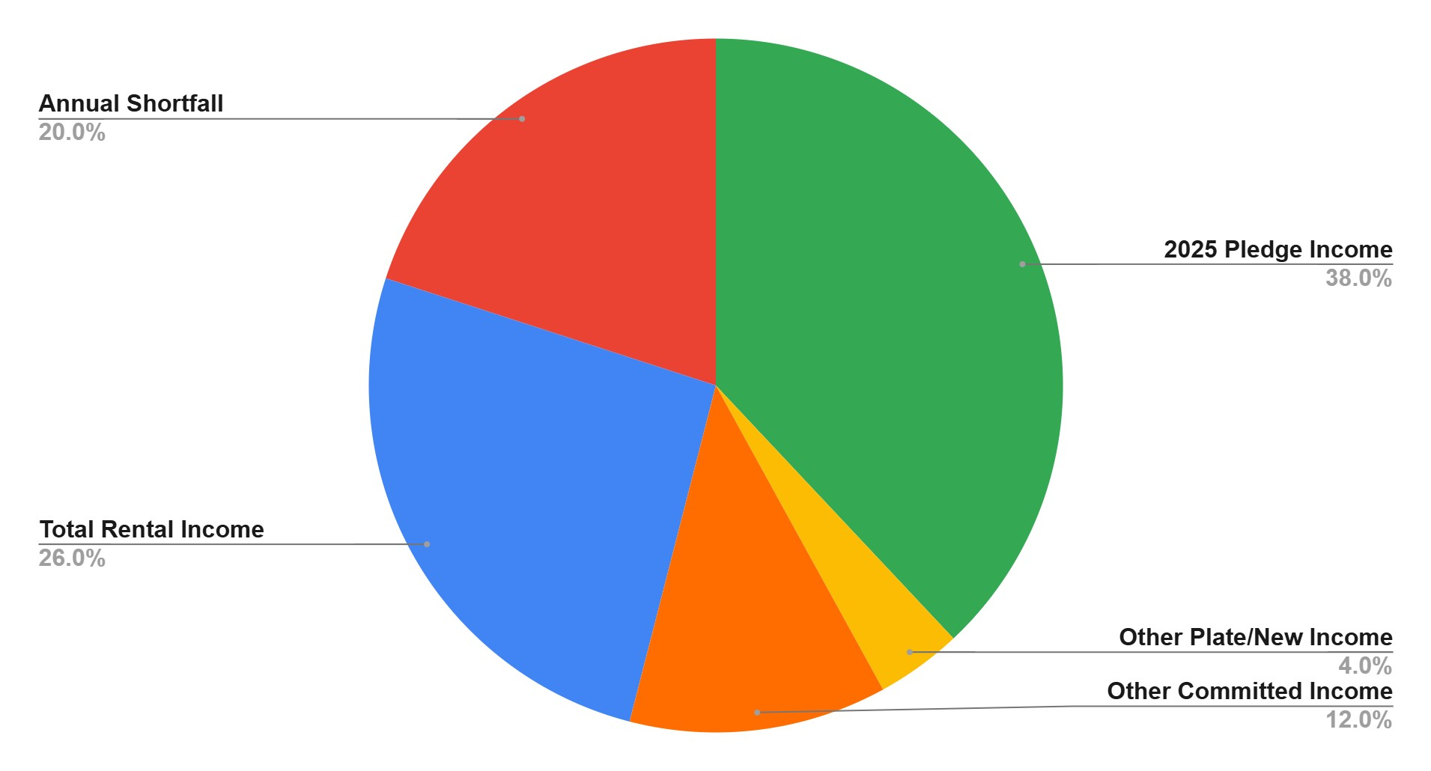
- Actual

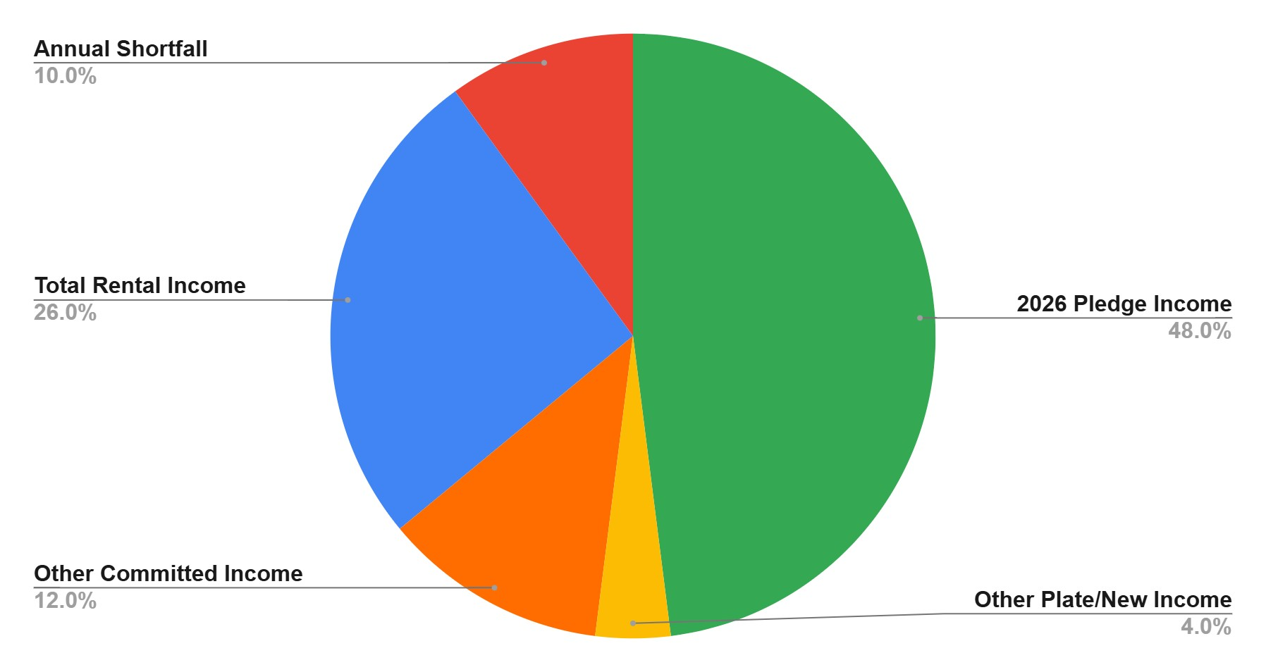
- Goal

Notice of Annual Meeting on November 9, 2025
(in the Sanctuary following the Sunday service)
Election of Vestry Members
Bylaws amendment and Vestry reconfiguration
On October 7, 2025, the Vestry of Saint Paul’s Elkins Park adopted new Bylaws effective on that date. These Bylaws streamline the process for electing Vestry members without multiple committees and designations of officiates. It is our hope that the new Bylaws will make it easier for the congregation and those serving on the Vestry to comply with legal requirements.
The new Bylaws provide that annual meetings of the congregation will occur in October or November of each year. At least three weeks’ notice of the annual meeting and election of Vestry members will be provided to the congregation. The total number of SPC Vestry members will include a minimum of 7 members from the SPC congregation, and a maximum of 9 members from the congregation. The Rector or Priest-in-Charge will serve on the vestry as a non-voting member. Church members are required to attend the annual meeting in person to cast votes for the election of Vestry members.
Terms of service on the Vestry: 3 years, with the possibility of a 3-year renewal. Annual dates of service for Vestry members: January 1 to December 31.
We are essentially at a new starting point with our new Bylaws, so we are staggering terms on the Vestry to provide for continuity and annual elections of members of the Vestry.
November 9, 2025: Candidates for the Vestry
Robert Lockyer: If elected, term would end December 31, 2026
Doug Martin: If elected, term would end December 31, 2026
Shango-Jamal Lewis: If elected, term would end December 31, 2027
Herb Welles: if elected, term would end December 31, 2027
Karen Jantzi: If elected, term would end December 31, 2028
Felicia Anyanwu: If elected, term would end December 31, 2028
Note: The Vestry is seeking nominations for an additional candidate.

