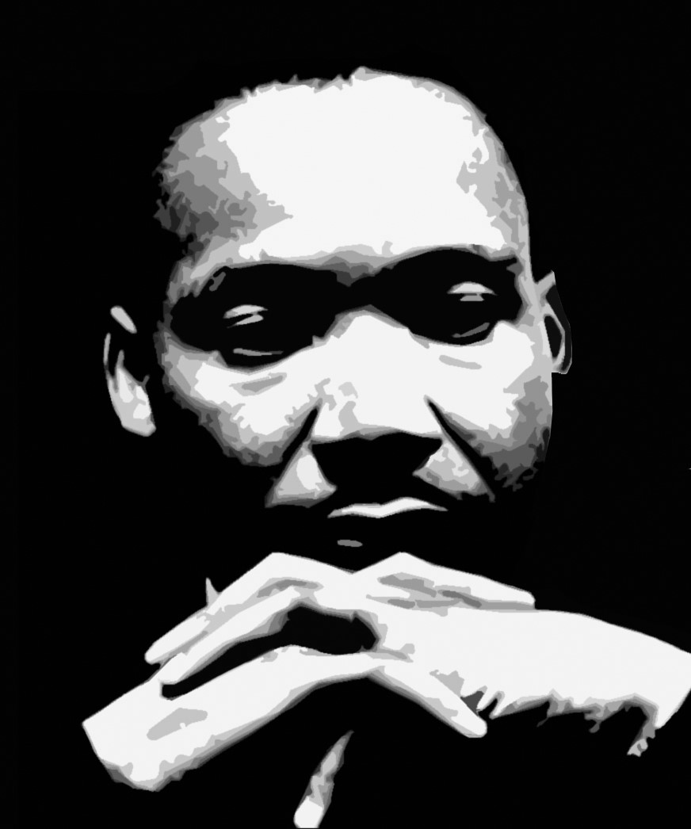


Second Sunday After The Epiphany January 18, 2026 9:00 a.m.
The Feast Day of Dr. Martin Luther King, Jr.

Welcome to St. Paul’s Elkins Park!
We are on a mission to know Christ; to make Christ known in our community; and to follow His Way of compassion and service to others.
The Rev. John D. Daniels, Priest in Charge
The Rev. Simpson Coriolan, Priest Associate
The Rev. Jeannie Sachs, Deacon
David Antony Lofton, Music Director
Tessika McClendon, Soprano
Veronica Flemings, Acolyte

Holy Eucharist
The Ministry of the Word
Prelude: Keep the Dream Alive Hezekiah Brinson Jr. Tessika McClendon, Soprano

WELCOME

Opening Hymn: Lift Every Voice and Sing LEVAS #1

Opening Sentence: Please Stand

Celebrant: Blessed be the Lord Our God.
People: For ever and ever.
Celebrant: We seek to walk the path of Christ.
People: May the Spirit be among us, in us, and through us.
Hymn of Glory: Blessed Martin, Pastor, Prophet, Blue # 46 (vs., refrain twice)
Celebrant: The Lord be with you. People: And also with you. Celebrant: Let us pray.

Almighty God, whose Son our Savior Jesus Christ is the light of the world: Grant that your people, illumined by your Word and Sacraments, may shine with the radiance of Christ’s glory, that he may be known, worshipped, and obeyed to the ends of the earth; through Jesus Christ our Lord, who with you and the Holy Spirit lives and reigns, one God, now and for ever. Amen

The First Lesson: A reading from the Old Testament: Isaiah 49:1-7
Please be seated for the readings.

Listen to me, O coastlands, pay attention, you peoples from far away! The Lord called me before I was born, while I was in my mother’s womb he named me. He made my mouth like a sharp sword, in the shadow of his hand he hid me; he made me a polished arrow, in his quiver he hid me away. And he said to me, “You are my servant, Israel, in whom I will be glorified.” But I said, “I have labored in vain, I have spent my strength for nothing and vanity; yet surely my cause is with the Lord, and my reward with my God.” And now the Lord says, who formed me in the womb to be his servant, to bring Jacob back to him, and that Israel might be gathered to him, for I am honored in the sight of the Lord, and my God has become my strength— he says, “It is too light a thing that you should be my servant to raise up the tribes of Jacob and to restore the survivors of Israel; I will give you as a light to the nations, that my salvation may reach to the end of the earth.”
Thus says the Lord, the Redeemer of Israel and his Holy One, to one deeply despised, abhorred by the nations, the slave of rulers, “Kings shall see and stand up, princes, and they shall prostrate themselves, because of the Lord, who is faithful, the Holy One of Israel, who has chosen you.”
Reader: The Word of the Lord. People: Thanks be to God.
Psalm: Psalm 40:1-12
I waited patiently upon the Lord; *
he stooped to me and heard my cry.
He lifted me out of the desolate pit, out of the mire and clay; *
he set my feet upon a high cliff and made my footing sure.
He put a new song in my mouth,
a song of praise to our God; *
many shall see, and stand in awe,
and put their trust in the Lord.
Happy are they who trust in the Lord! *
they do not resort to evil spirits or turn to false gods. Great things are they that you have done, O Lord my God!
how great your wonders and your plans for us! *
there is none who can be compared with you.
Oh, that I could make them known and tell them! *
but they are more than I can count.
In sacrifice and offering you take no pleasure *
(you have given me ears to hear you);
Burnt-offering and sin-offering you have not required, *
and so I said, “Behold, I come.
In the roll of the book it is written concerning me: *
‘I love to do your will, O my God;
your law is deep in my heart.”‘
I proclaimed righteousness in the great congregation; *
behold, I did not restrain my lips;
and that, O Lord, you know.
Your righteousness have I not hidden in my heart;
I have spoken of your faithfulness and your deliverance; *
I have not concealed your love and faithfulness from the great congregation.
¹You are the Lord;
do not withhold your compassion from me; *
let your love and your faithfulness keep me safe for ever,
The Second Lesson: 1 Corinthians 1:1-9
Paul, called to be an apostle of Christ Jesus by the will of God, and our brother Sosthenes, To the church of God that is in Corinth, to those who are sanctified in Christ Jesus, called to be saints, together with all those who in every place call on the name of our Lord Jesus Christ, both their Lord and ours: Grace to you and peace from God our Father and the Lord Jesus Christ. I give thanks to my God always for you because of the grace of God that has been given you in Christ Jesus, for in every way you have been enriched in him, in speech and knowledge of every kind— just as the testimony of Christ has been strengthened among you— so that you are not lacking in any spiritual gift as you wait for the revealing of our Lord Jesus Christ. He will also strengthen you to the end, so that you may be blameless on the day of our Lord Jesus Christ. God is faithful; by him you were called into the fellowship of his Son, Jesus Christ our Lord.
Hear what the Spirit is saying to God’s people. People: Thanks be to God.

Gospel Hymn: Jesus Came to Earth from Glory LEVAS #23
The Gospel: All Stand for the reading of the Gospel Celebrant: Holy Gospel of our Lord Jesus Christ according to John 1:29-42
The next day he saw Jesus coming toward him and declared, “Here is the Lamb of God who takes away the sin of the world! This is he of whom I said, ‘After me comes a man who ranks ahead of me because he was before me.’¹I myself did not know him; but I came baptizing with water for this reason, that he might be revealed to Israel.” And John testified, “I saw the Spirit descending from heaven like a dove, and it remained on him. I myself did not know him, but the one who sent me to baptize with water said to me, ‘He on whom you see the Spirit descend and remain is the one who baptizes with the Holy Spirit.’ And I myself have seen and have testified that this is the Son of God.” The next day John again was standing with two of his disciples, and as he watched Jesus walk by, he exclaimed, “Look, here is the Lamb of God!”
The two disciples heard him say this, and they followed Jesus. When Jesus turned and saw them following, he said to them, “What are you looking for?” They said to him, “Rabbi” (which translated means Teacher), “where are you staying?” He said to them, “Come and see.” They came and saw where he was staying, and they remained with him that day. It was about four o’clock in the afternoon. One of the two who heard John speak and followed him was Andrew, Simon Peter’s brother. He first found his brother Simon and said to him, “We have found the Messiah” (which is translated Anointed). He brought Simon to Jesus, who looked at him and said, “You are Simon son of John. You are to be called Cephas” (which is translated Peter).
Celebrant: The Gospel of the Lord People: Praise to you, Lord Christ.
The Homily: The Rev. Jeannie Sachs, Deacon
The Nicene Creed All Stand as you are able Our Affirmation of Trust in all that is Holy We believe in one God, the Father, the Almighty, maker of heaven and earth, of all that is, seen and unseen. We believe in one Lord, Jesus Christ, the only Son of God, eternally begotten of the Father, God from God, Light from Light, true God from true God, begotten, not made, of one Being with the Father. Through him all things were made. For us and for our salvation he came down from heaven: by the power of the Holy Spirit, he became incarnate from the Virgin Mary and was made man. For our sake he was crucified under Pontius Pilate; he suffered death and was buried. On the third day he rose again in accordance with the Scriptures; he ascended into heaven and is seated at the right hand of the Father. He will come again in glory to judge the living and the dead, and his kingdom will have no end. We believe in the Holy Spirit, the Lord, the giver of life, who proceeds from the Father and the Son. With the Father and the Son he is worshiped and glorified. He has spoken through the Prophets. We believe in one holy catholic and apostolic Church. We acknowledge one baptism for the forgiveness of sins. We look for the resurrection of the dead, and the life of the world to come. Amen.
Prayers of the People: (The Reader and People pray responsively)
In peace, we pray to you, Lord God. (Silence) For all people in their daily life and work; For our families, friends, and neighbors, and for those who are alone. For Congress and the President, for peace among the nations, for all those in uniform now serving in harm’s way, and for those who suffer for the sake of conscience. For all who work for justice, freedom, and peace. For the just and proper use of your creation; For the victims of hunger, fear, injustice, and oppression. For all who are in danger, sorrow, or any kind of trouble; For those who minister to the sick, the friendless, and the needy. Give us hope in this time of uncertainty. Strengthen those who are afraid and give us courage in the face of violence and hate. Open our hearts and the hearts of our enemies to your ways of peace; break down the walls that divide us. Make us instruments of reconciliation and show forth your love. For the peace and unity of the Church of God; For all who proclaim the Gospel, and all who seek the Truth. For Sean, our Presiding Bishop, for Daniel, our Diocesan Bishop; for John, our Priest in Charge, for Simpson, our Priest Associate, for Jeannie, our Deacon, for David our Music Director, for Tessika and Shango-Jamal, our singers, for Veronica Flemings, our acolyte, for all bishops and other ministers, and for all people everywhere; For all who serve in God’s Church. For the special needs and concerns of this congregation, (The People may add their own petitions, either silently or aloud) Hear us, Lord; For your mercy is great. We thank you, Lord, for all the blessings of this life. (The People may add their own thanksgivings either silently or aloud) We will exalt you, O God our King; And praise your Name for ever and ever. We pray for all who have died, that they may have a place in your eternal kingdom. (The People may pray for those who have died, silently or aloud.) Lord, let your loving-kindness be upon them; Who put their trust in you.
Celebrant and People: Almighty God, to whom our needs are known before we ask, help us to ask only what accords with your will; and those good things which we dare not, or in our blindness cannot ask, grant us for the sake of your Son Jesus Christ our Lord. Amen.
Confession of Sin: Celebrant Let us confess our sins against God and our neighbors. Celebrant and People Most merciful God, we confess that we have sinned against you in thought, word, and deed, by what we have done, and by what we have left undone. We have not loved you with our whole heart; we have not loved our neighbors as ourselves. We are truly sorry and we humbly repent. For the sake of your Son Jesus Christ, have mercy on us and forgive us; that we may delight in your will, and walk in your ways, to the glory of your Name. Amen.
Celebrant: Almighty God have mercy on you, forgive you all your sins through our Lord Jesus Christ, strengthen you in all goodness, and by the power of the Holy Spirit keep you in eternal life. Amen.
The Peace: (All stand.) Celebrant: The peace of Christ be always with you. People: And also with you. (The Ministers and People greet one another in the name of the Lord.)
Words of Welcome and Announcements

The Holy Communion
Eucharistic Prayer
Offertory Anthem: If I Can Help Somebody by Alma Bazel Androzzo Tessika McClendon, Soprano
The Doxology #380 verse Praise God from whom all blessings flow Praise Him all creatures here below Praise Him above ye heavenly host Praise Father, Son and Holy Ghost. Amen.
Celebrant: The Lord be with you. People: And also with you. Celebrant: Lift up your hearts. People: We lift them up to the Lord. Celebrant: Let us give thanks to the Lord our God. People: It is right to give our thanks and praise.

Facing the Holy Table, the Celebrant says It is truly right, and good and joyful, to give you thanks, all-holy God, source of life and fountain of mercy. You have filled us and all creation with your blessing and fed us with your constant love; you have redeemed us in Jesus Christ and knit us into one body. Through your Spirit you replenish us and call us to fullness of life. Therefore, joining with Angels and Archangels and with the faithful of every generation, we lift our voices with all creation as we sing:

Celebrant and People: Sanctus Blue Hymnal # S 124
Holy, Holy, Holy, Lord, God of power and might,
Heaven and earth are full of your glory.
Hosanna in the highest.
Blessed is he who comes in the name of the Lord.
Hosanna in the highest.
Celebrant: Blessed are you, gracious God, creator of the universe and giver of life.
You formed us in your own image and called us to dwell in your infinite love. You gave the world into our care that we might be your faithful stewards. But we failed to honor your image in one another and in ourselves; we would not see your goodness in the world around us; and so we violated your creation, abused one another, rejected your love. Yet you never ceased to care for us, and prepared the way of salvation for all people. Through Abraham and Sarah, you called us into covenant with you. You delivered us from slavery, sustained us in the wilderness, and raised prophets to renew your promise of salvation. Then, in the fullness of time, you sent your eternal Word, made mortal flesh in Jesus. Born into the human family, and dwelling among us, he revealed your glory. Giving himself freely to death on the cross, he triumphed over evil, opening the way of freedom and life.
On the night before he died for us, Our Savior Jesus Christ took bread, and when he had given thanks to you, he broke it, and gave it to his friends, and said: “Take, eat: This is my Body which is given for you. Do this for the remembrance of me.” As supper was ending, Jesus took the cup of wine, and when he had given thanks, he gave it to them, and said: “Drink this, all of you: This is my Blood poured out in forgiveness. Whenever you drink it, do this for the remembrance of me.”

Therefore, we proclaim the mystery of faith: Celebrant and People:
Christ has died. Christ is risen. Christ will come again.
Celebrant: Remembering his death, resurrection, and ascension, we now present to you from your creation this bread and this wine. By your Holy Spirit may they be for us the Body and Blood of our Savior Jesus Christ. Grant that we who share these gifts may be filled with the Holy Spirit and live as Christ’s Body in the world. Bring us into the everlasting heritage of your daughters and sons, that with St. Paul and all your saints, past, present, and yet to come, we may praise your Name forever. Through Christ and with Christ and in Christ, in the unity of the Holy Spirit, to you be honor, glory, and praise, forever and ever. Amen.
Celebrant: And now, let us say together the words Our Savior taught us, Celebrant and People:
Our Father, who art in heaven as we forgive those
Hallowed be thy Name who trespass against us,
Thy kingdom come, and lead us not into temptation,
Thy will be done, but deliver us from evil,
On earth as it is in heaven. for thine is the kingdom,
Give us this day our daily bread, and the power, and the glory,
And forgive us our trespasses, forever and ever. Amen
The Breaking of the Bread (The Celebrant breaks the consecrated Bread.)
Celebrant: We break this bread to share in the Body of Christ. People: We who are many are one body, for we all share in the one bread and the one cup. Alleluia
Agnus Dei Blue Hymnal # S161
Lamb of God, you take away the sins of the world.
Have mercy on us.
Lamb of God you take away the sins of the world
Have mercy on us.
Lamb of God you take away the sins of the world, Grant us peace.
Celebrant: The Gifts of God for the People of God. All are welcome at the Lord’s table. Take them in remembrance that Christ died for you, and feed on him in your hearts by faith, with thanksgiving. The ministers receive the Sacrament in both kinds, and then immediately deliver it to the people. The Bread and the Cup are given to the communicants.

Post Communion Prayer: After Communion, the Celebrant says, Let us pray.

Celebrant and People
Loving God, we give you thanks for restoring us in your image, and nourishing us with spiritual food in the Sacrament of Christ’s Body and Blood.
Now send us forth a people, forgiven, healed, renewed; that we may proclaim your love to the world and continue in the risen life of Christ our Savior. Amen.

The Blessing:
Celebrant: The blessing of God Almighty, Creator, Redeemer, and Sanctifier, be with you and with those you love, this day, and for ever more. People: Amen.
Closing Hymn: We Shall Overcome LEVAS #227 vs. 1, 3, 5
The Dismissal: Celebrant: Let us go forth into the world, rejoicing in the power of the Spirit. Alleluia. Alleluia. People: Thanks be to God. Alleluia, Alleluia

Postlude: Jesus Is All The World To Me Will Thompson arr. Mark Hayes
**

To quote Dr. King, “Life’s most persistent and urgent question is, ‘What are you doing for others?’”

Martin Luther King Jr. Day is this Monday, January 19. The federal holiday was signed into law by then President Ronald Reagan in 1983, but the idea for a National Day of Service evolved later.

The national Martin Luther King Jr. Day of Service was started by Harris Wofford, a former US Senator from Pennsylvania, and Georgia Congressman John Lewis. They co-authored the King Holiday and Service Act of 1994, which challenges Americans to transform the King Holiday into a day of volunteer service in honor of the life and work of the Reverend Dr. Martin Luther King Jr. and to make a difference in their communities.

**

Please join us in the Narthex following the service for Coffee Hour.

January Birthday’s
15 – Fr. John Daniels 09 – Swayer Hammond 16 – Elizabeth Pillsbury 24 – Gloria Amachi 26 – Will Mathis 27 – Jeremiah Sime 29 - Karen Jantzi 29 – Fr. Coriolan Simpson

TODAY!!!
SOUNDBATH –
Sunday, January 18th, 2-3:30 p.m.
Tickets still Available!
St. Paul's Women's Book Club
The next meeting of St. Paul's Women's book club will be Wednesday, January 28, 2026, at 7 p.m. Carlene Wells is hosting at 811 Chelten Hills Drive. We will be discussing Three Days in June by Anne Tyler. Please join us!

Save the Date: April 11, 2026 4p.m. –A Recital with Tessika McClendon soprano, Belinda Whitnley, violin, David Anthony Lofton, Piano.
Featuring music of John Carter, Ernest Chausson, Camille Saint-Saems, James H. Easst, Sergei Rachmaninoff, and Moses Hogan. April

New Worship Committee – The Worship Committee is forming and will meet the 4st Sunday of every month following the 9 am service. Committee members offer support and planning to the ministers, during regular and special services. Members include Greeters/Ushers, Acolytes, Altar Guild and anyone interested in helping.
Please contact Karen Bailey for more information.

The Prayer Shawl Knitting Group. Meets the 2nd Saturday of every month,
10a.m. to 12p.m.


An Inclusive Multicultural Episcopal Church
We are on a mission to know Christ and follow His Way of compassion
and service.
Fundamental Fairness
Do not let people disappear!
We support due process - a fundamental principle of fairness in legal proceedings, ensuring that individuals are treated fairly by the government.
We celebrate multicultural traditions. We are faithful, caring, and accepting.
All Are Welcome – No Exceptions
Please Join Us!
Family Communion, Sunday 9:00am
St. Paul’s Church, 7809 Old York Road Elkins Park, PA 19027 (215-635-4185) stpaulselkinspark.org office@stpaulselkinspark.org

